4G-TRAVEL



**Guzalya Kholdorova - U1910124**

**Umida Abdukadirova - U1910095**

**Sevinch Makhmudova - U1910052**

**Oltinoy Toshmuradova - U1910047**

LINK TO THE GIT: https://github.com/iuthub/group-project-4g

LINK TO THE WEB-SITE: https://oltinoy1221.github.io/

# CONTENT

ABOUT US 1

FUNCTIONALITY OF THE SITE 1

CONTRIBUTION 10

NAME OF MEMBER 10

CHOSEN PART 10

THE WORK DONE 10

LOGINS AND PASSWORDS 10

# ABOUT US

# The theme of the project is a travel blog. On the site, the author can post photos, articles, talk about himself, and users, in turn, exchange opinions and learn a lot about the world around them.

# FUNCTIONALITY OF THE SITE

1. **HOME PAGE.** Having entered the site, the first thing that catches your eye is the main page. The functionality of the main page includes a navigation bar in the header of the site, a little information about us and contacts for feedback.

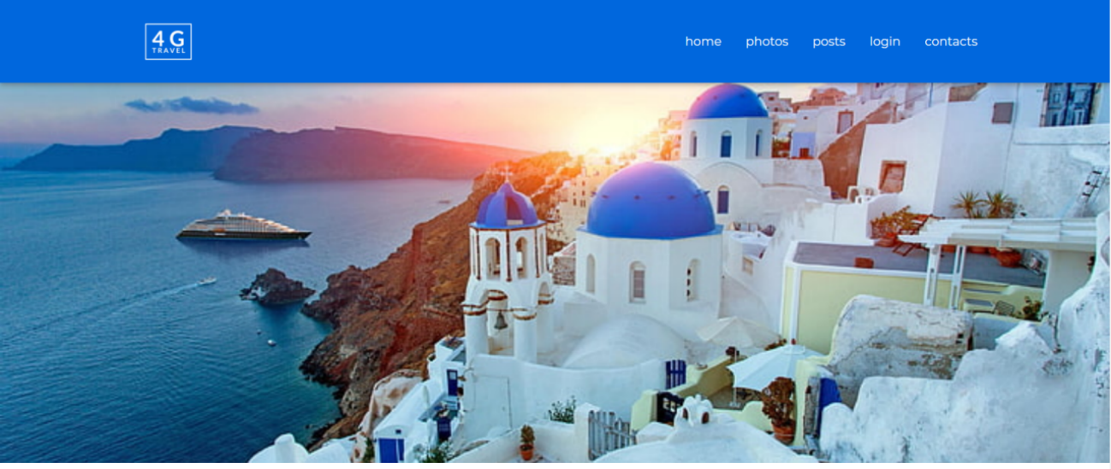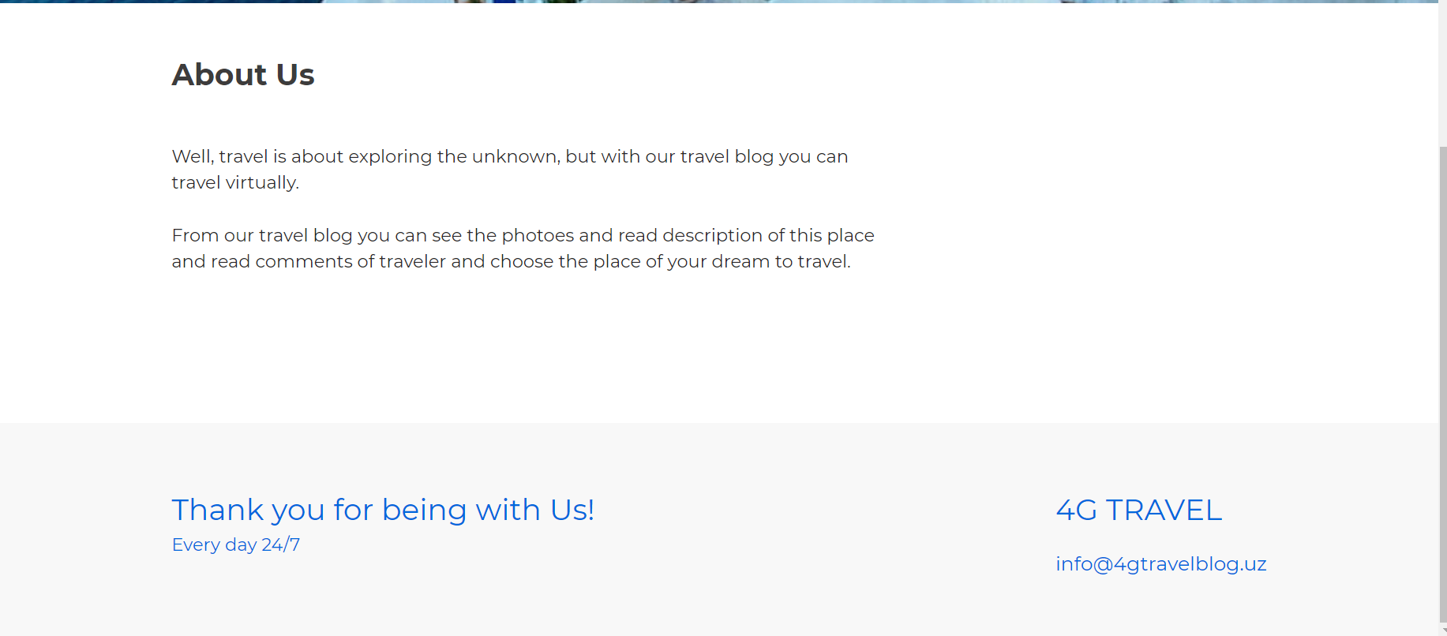

1. **NAVIGATION BAR.** A navigation bar is present in every part of the site and helps the user cross the website without much difficulty.



1. **PHOTOS.** This section is a small gallery. All photos are sorted into albums and united by a specific theme.

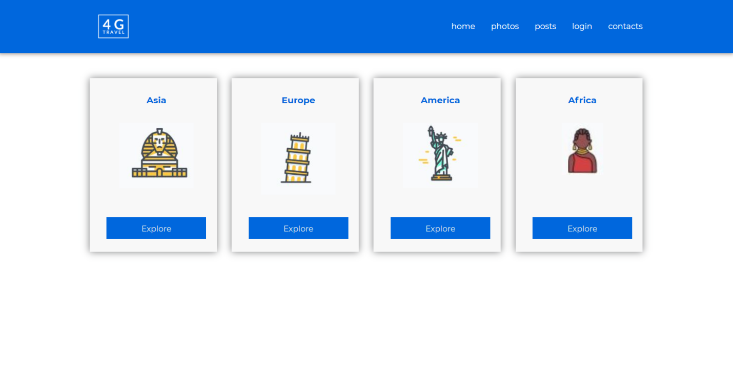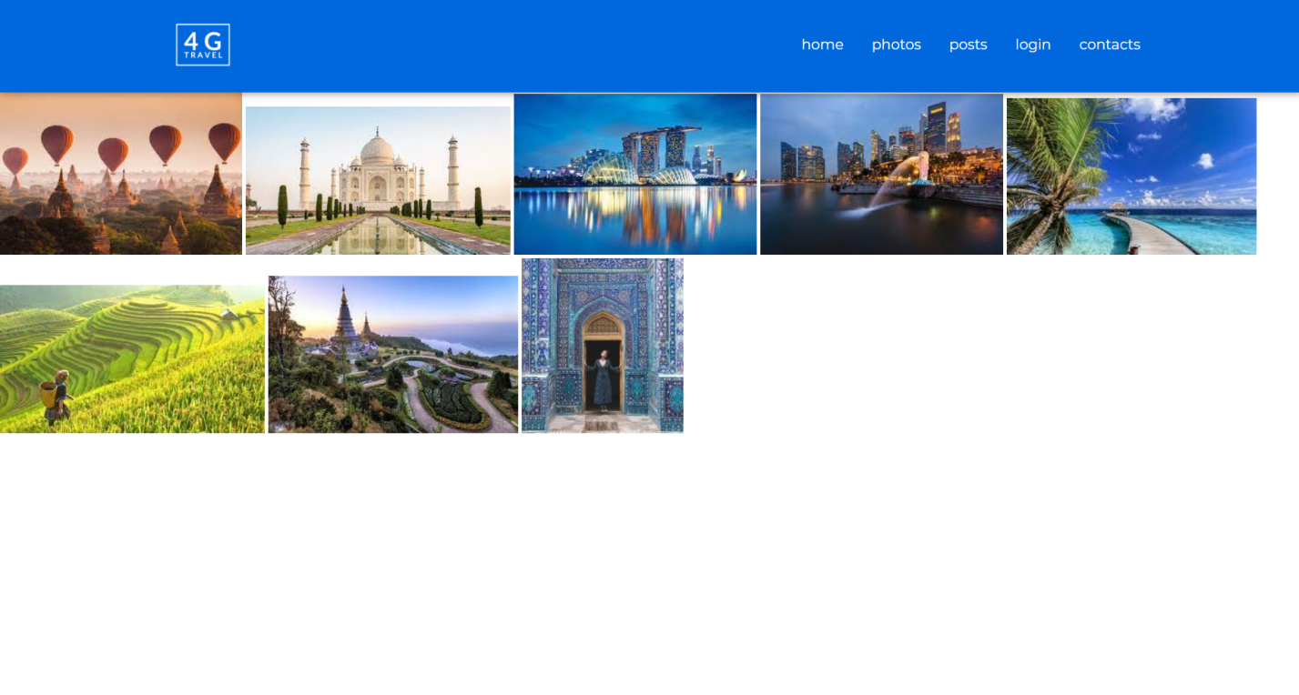

1. **POSTS.** In addition to the gallery, which contains only photos, the site has a "posts" section. It is in it that the main essence of the site lies. In the beginning, as in the previous section, there is navigation through the articles. The search capability is also included.

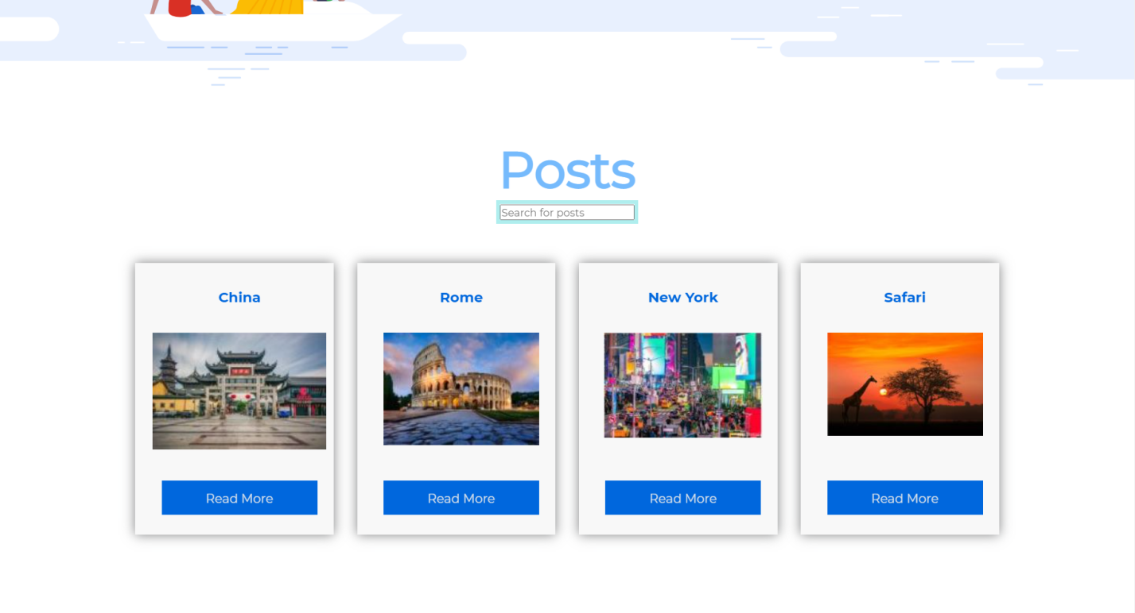

The article itself includes a block with constantly changing pictures, several paragraphs about the topic, and a window for comments.

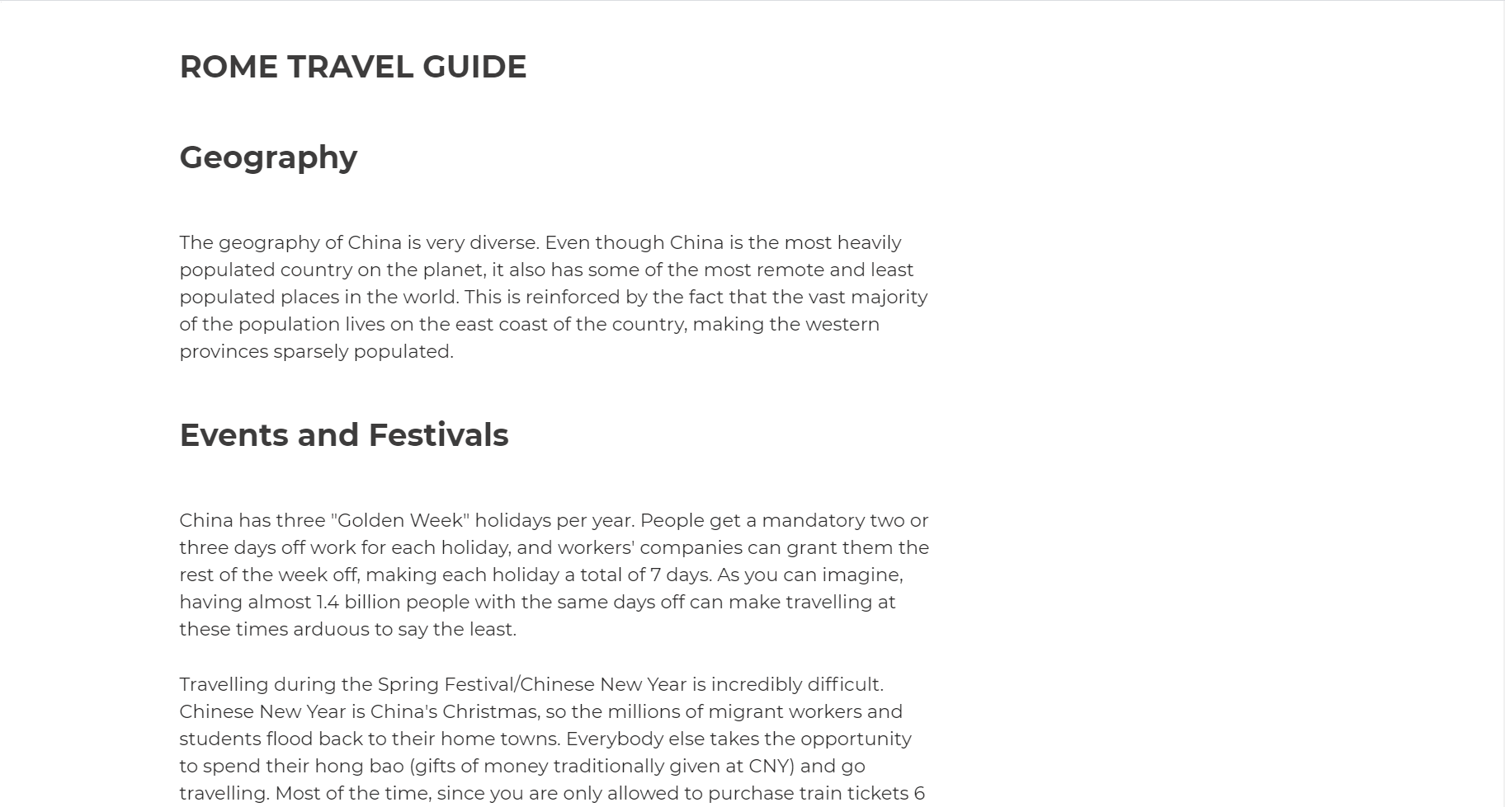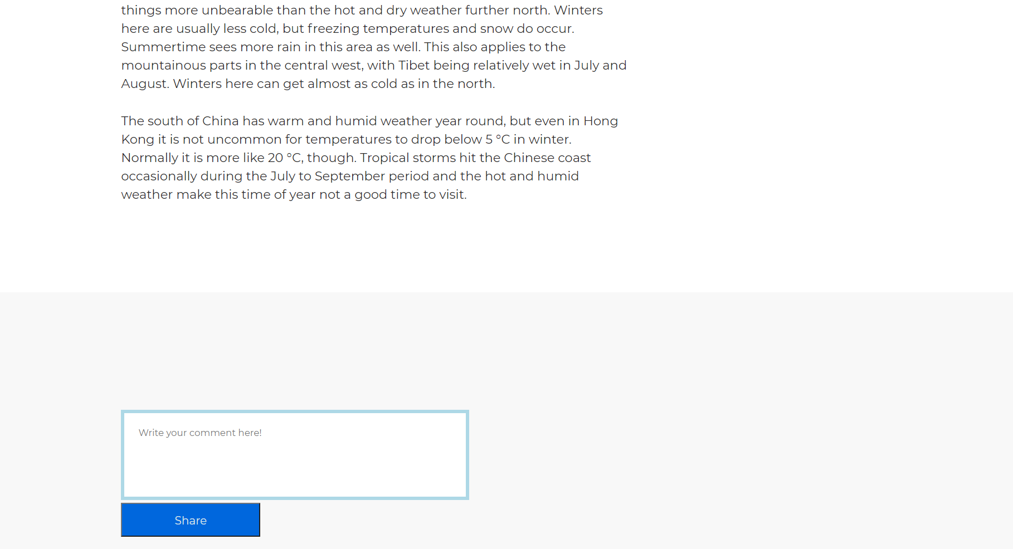

1. **LOGIN PAGE.** This part allows user to authorize in the site.

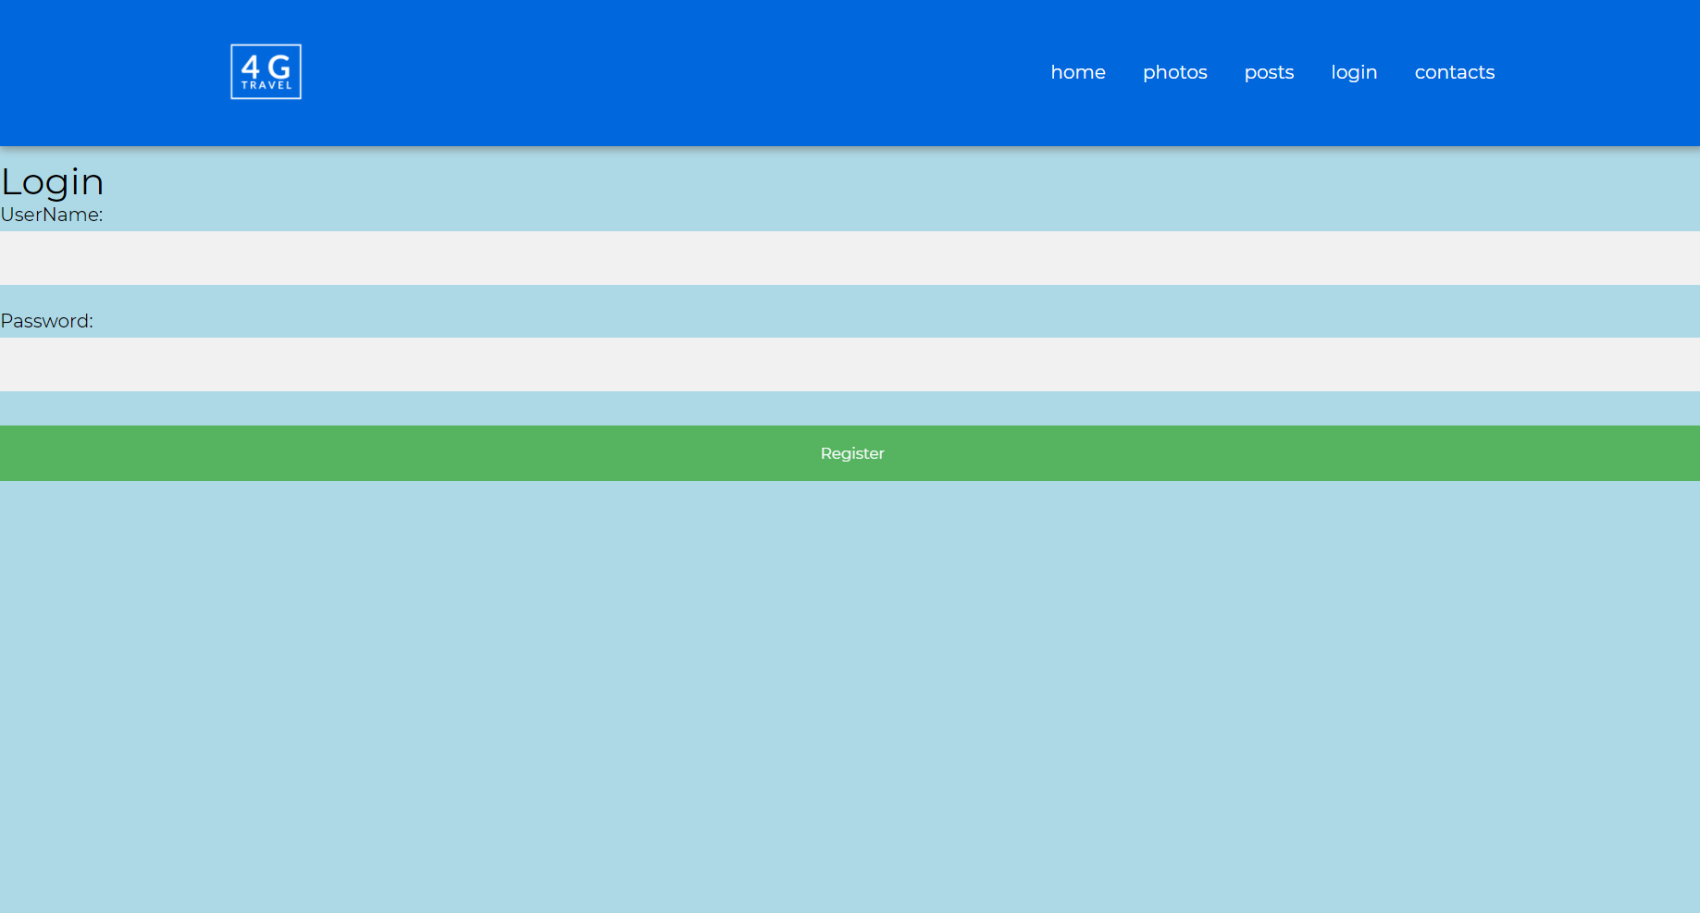

1. **CONTACTS .** The feedback could be given in that part, so there is no need to exit the site to communicate with author.

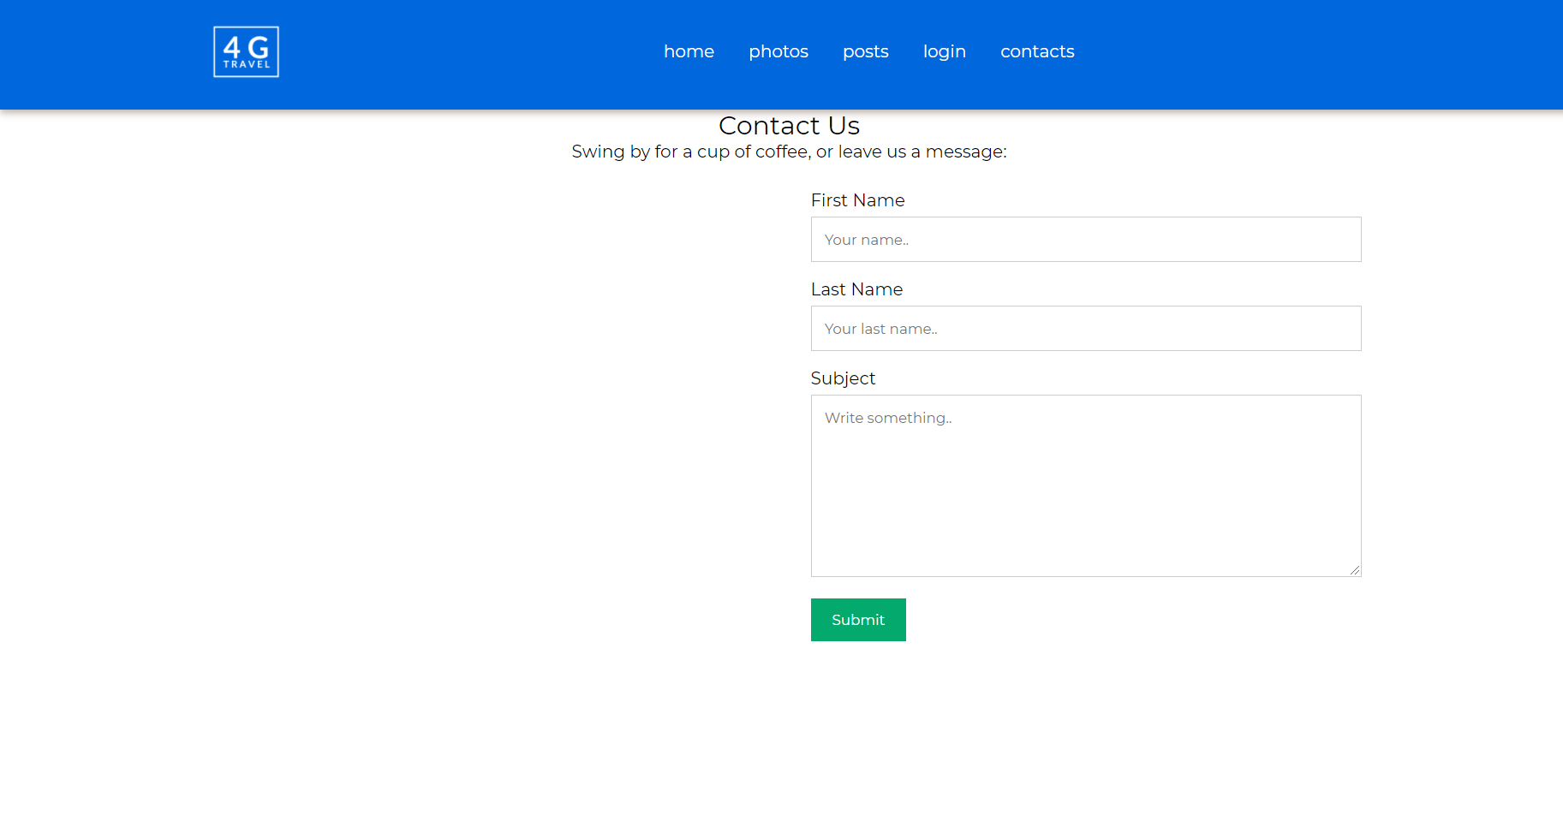

1. **DATABASE.** The site has its own database that has been written with MySQL. There are two examples of right and wrong authorization bellow.

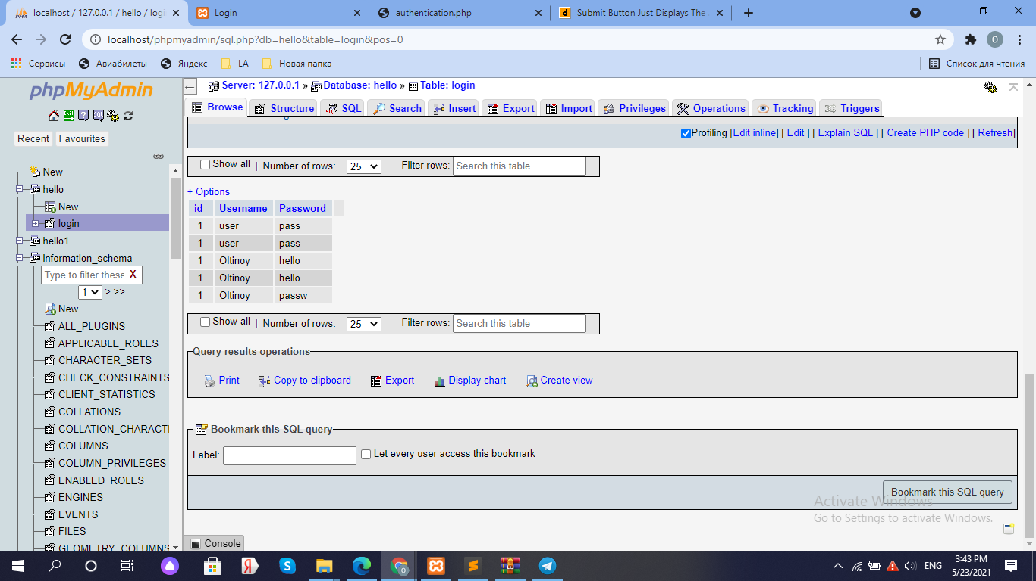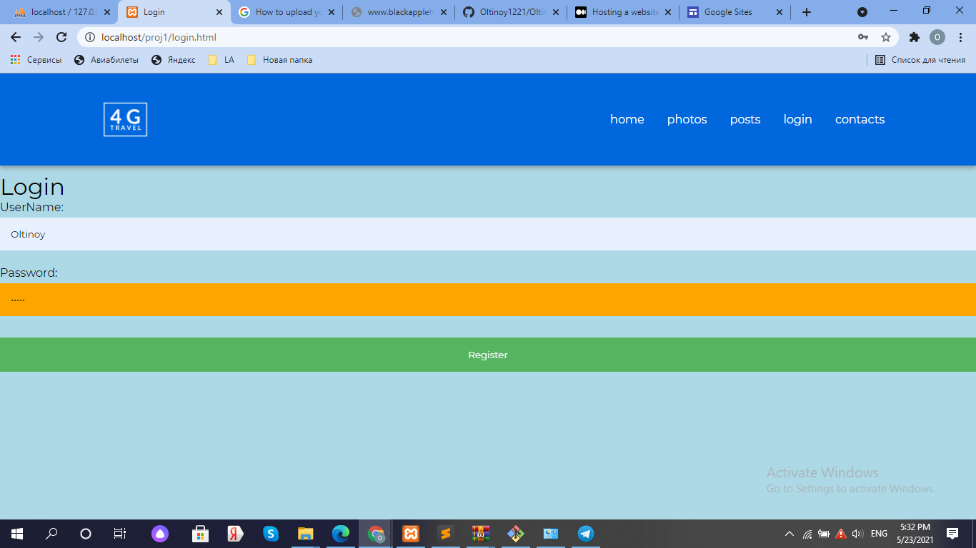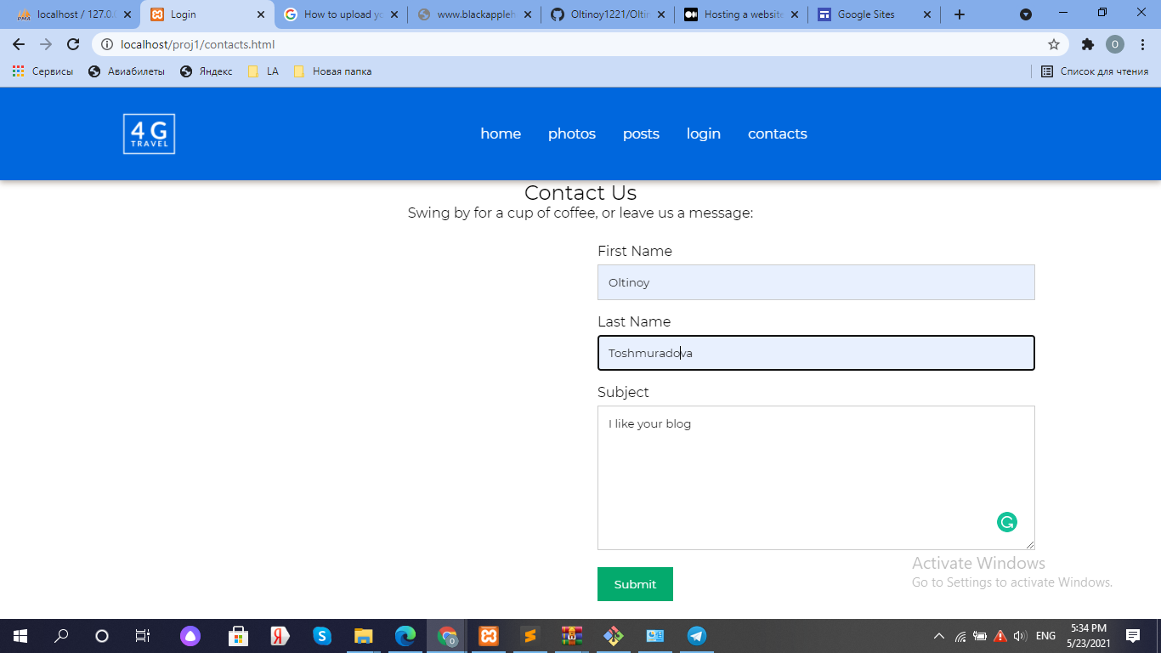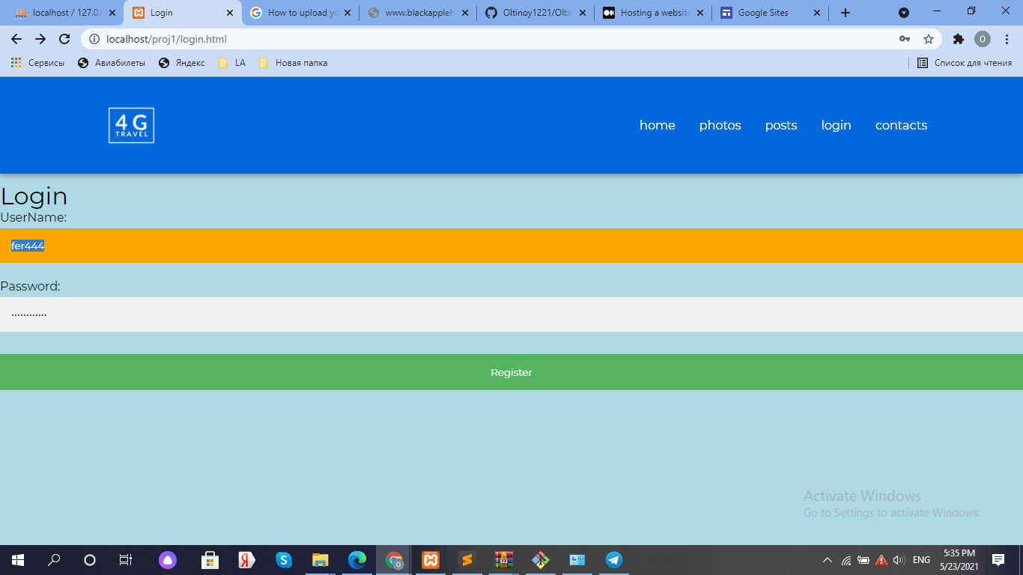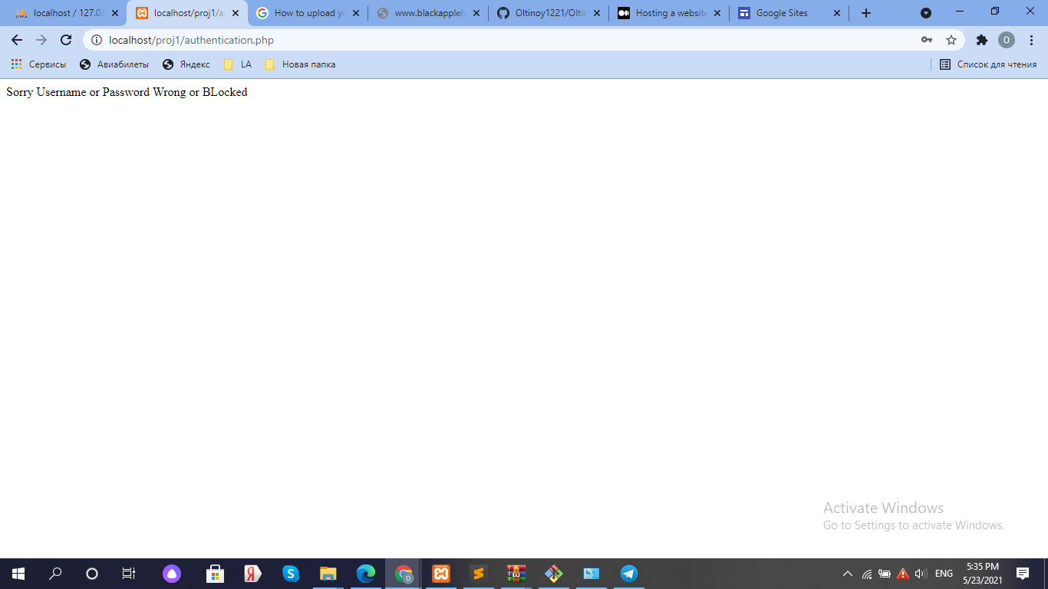

# 

# CONTRIBUTION

|  |  |  |
| --- | --- | --- |
| NAME OF MEMBER | CHOSEN PART | THE WORK DONE |
| Guzalya Kholdorova | Report, content, front-end | Has written the report and done css part. |
| Umida Abdukadirova | Content, Front-end | Searched for a content of the site and done front-end part of “posts” section. |
| Sevinch Makhmudova | Front-end | Done front-end part for “home” and “contacts” pages. |
| Oltinoy Toshmuradova | Front-end, back-end | Has done “login” page and connected to the back-end. |

# LOGINS AND PASSWORDS

Since the post are added to the site only from admin account, the blogger has to type following login and password to access “create new post” page.

Login - Oltinoy

Password - hello

# 